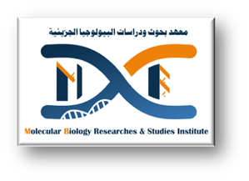



**Noura Ahmed Mohamed Ali**

**Personal information**

**Email nouraahmed 1299@gmail.com**

**Mobile number 01094587882**

**Academic education**

**2019 – 2023**

Faculty of Agriculture ,Assiut University.

**Academic positions**

**18/4/2024 – now**

Demonstrator at Biotechnology Department, Molecular Biology Researches & Studies

Institute, Assiut University, Assiut, Egypt**.**

**Language skills:**

Arabic native language

English good knowledge

**Researcher information**

**Official website:**

noura_ahmed @aun.edu.eg

**Google Scholar website:**

https://scholar.google.com.eg/citations?user=VgK52YQAAAAJ&hl=en